[**Module 02 – Visualization Tools**](https://learning.rasmussen.edu/webapps/blackboard/content/listContent.jsp?course_id=_67422_1&content_id=_6076795_1&mode=reset)

**Reading** -

* *Data Visualization: A Successful Design Process*
  + Permalink: <http://go.oreilly.com/rasmussen-college/library/view/data-visualization-a/9781849693462/ch04.html>
* *Storytelling with Data: A Data Visualization Guide for Business Professionals*
  + Chapter 2 Choosing an effective visual
    - Permalink: <http://go.oreilly.com/rasmussen-college/library/view/storytelling-with-data/9781119002253/c02.xhtml>
  + Chapter 3 Clutter is your enemy!
    - Permalink: <http://go.oreilly.com/rasmussen-college/library/view/storytelling-with-data/9781119002253/c03.xhtml>
* [Maps in Tableau](https://content.learntoday.info/Learn/QMB3300fw_Summer_17/qmb3300fw-summer-17/media/maps_in_tableau_transcript.pdf)
* [Custom Geocoding](https://content.learntoday.info/Learn/QMB3300fw_Summer_17/qmb3300fw-summer-17/media/custom_geocoding_transcript.pdf)

*Activity Time: 6 hours*

Visualization Tools

Data visualization can be accomplished in many ways using different software applications. Data visualization tools have common features which cause them all to be similar, and a few which sets them apart. Widespread access to tools such as Microsoft Excel over a long period of time has led to de facto industry standards, and typical graphs that people have become accustomed to seeing. The market today, however, includes data visualization tools which go far beyond the capabilities of Excel. In fact, most data visualization tools have the ability to ingest spreadsheets from Excel and then provide the user with the power and functionality of its own application. As these tools are compared, it would be good to have a foundation in knowing the types of features used in data visualization today.

**Common Graph Types Used in Data Visualization Tools**

* Bar chart
* Pie chart
* Line chart
* Scatter plot
* Heat map
* Geospatial map
* Bubble chart
* Histogram

While there are certainly other graph types which can be used to represent data, these are some of the most common. In a previous module, research companies were discussed as being considered credible data sources. Research companies are well known for their industry comparisons by using a quadrant comparison. It is a bubble chart that compares competitors in a given industry based upon their ability to deliver and the advancement of the company vision. Below is are examples of the typical Quadrant layout. The first layout shows the general format and meaning. The second layout includes the bubbles for companies and shows them positioned in the quadrants.

*Figure 2-1 Research Quadrant Definitions*

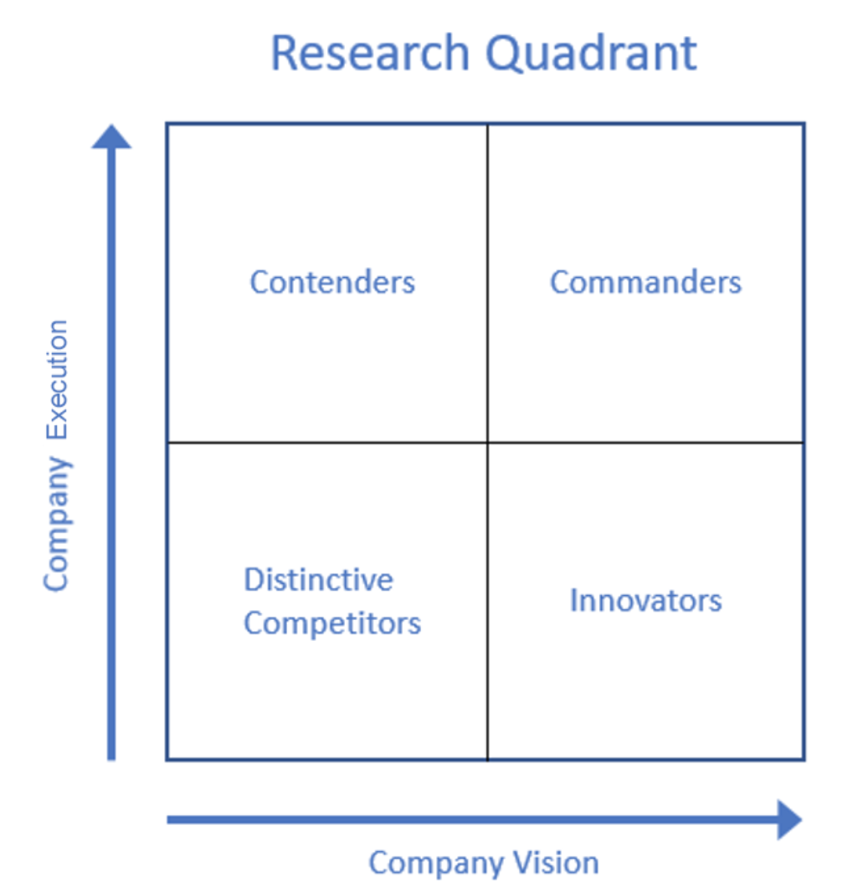

Below is an example of a Research Quadrant for Business Intelligence Platforms. This is a fictitious example to demonstrate how companies may compare within a research quadrant. From this view, it can be seen how companies are positioned on the Quadrant. But the size of the bubble is uniform and not an indication of company performance. The position of the bubble on the quadrant is what distinguishes each company. The x-axis represents the completeness of the company vision and the y-axis represents the ability to execute.

*Figure 2-2 Research Quadrant Company Comparison*

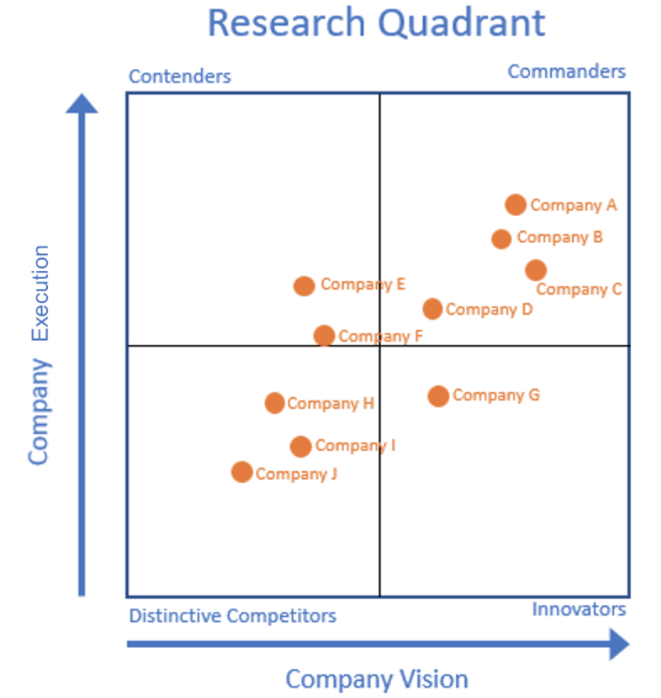

In this next example sourced from Tableau, the scatter plot is enhanced with bubble sizing, and used in conjunction with a quadrant view. Don’t be confused because this is not a Gartner Magic Quadrant, just a quadrant layout to compare four different types of characters in this example. Additional detail about the characters would be added below the chart as text.

*Figure 2-3 Geospatial Map (Source: Tableau)*

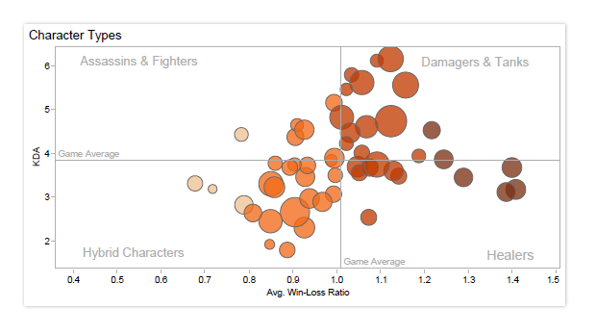

Yet another view of a Geospatial Map enhanced with bubbles is shown below. From this view, the audience gets an understanding of a dataset by comparing two colors across different regions of the world. The size of the bubbles are automatically scaled across the range of values in the dataset. In this case, the audience would need to have some sense of geography and countries.

*Figure 2-4 Bubble Map (Source: Tableau)*

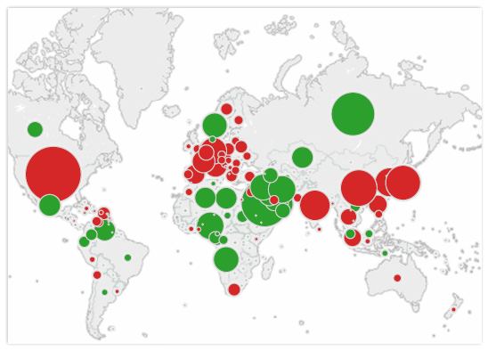

This next view is of a histogram. A histogram shows how data is distributed across groups or categories. Let’s say that you work for a bank that has a large portfolio of mortgages. Perhaps the bank would be interested in knowing if properties are distressed in a given area. Banks often measure their own mortgage notes by delinquency, but they also need to understand their risks for lending. In the histogram below, a view is given by the number of properties sold, the price range, county, and month. It is also characterized by a level of distress, that being either: short sale, bank owned or not distressed. From this histogram view, it can easily be determined that houses up to $250K are the most distressed with bank owned and short sales.

Now let’s say that the bank wanted to create a new data set to drill further down into this demographic and understand how it compares to the remaining properties. One way to do this would be to join the underlying data in this histogram with additional data about the homeowners. For instance, a bank may be interested in adding income, household size, and number of years owned to their analysis. With each layer of information that gets added, a better understanding of the homeowner’s profile can be seen. Bear in mind though, that such data joins can indicate a correlation of data, a trend or theme. It will not factor in other elements of a homeowner’s profile such as lifestyle, illness, divorce, or temporary job loss. All factors which can impact the results seen in the histogram.

*Figure 2-5 Histogram of Home Sales (Source: Tableau)*

*This histogram shows which houses are seeing the most sales in a month.*

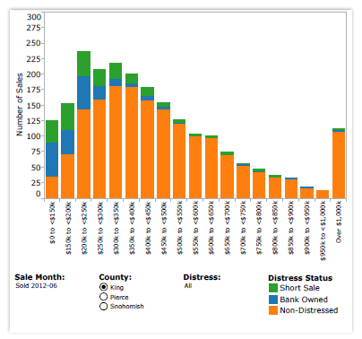

In conclusion, the examples above survey some of the capabilities of data visualization tools and highlight some of the features. When comparing various data visualization tools currently on the market today, additional consideration must be given to: cost, time to deploy, ease of use, training, and support.

Mapping for Insight

The science of geospatial mapping has been around for many years. Maps truly simplify a world of information down to what seems to be a single page. Maps do more than just convey geographies, and today’s maps are far more advanced as visualization tools than ever before. Maps contain vital information about a particular context that informs a user in a way that cannot be done with a simple chart or graph. One example of data visualization and the use of maps can be seen in the area of weather reporting.

The National Oceanic and Atmospheric Administration has a central repository of many types of weather events from around the globe. Weather is an area where various forecast models are used to predict weather conditions. In Figures 1 & 2 below, the total amount of rainfall can be seen in two different time periods which are 10 days apart. In Figure 1 the total rainfall is measured on April 30, 2017. In Figure 2, the total rainfall is measured on May 10, 2017 which represents a prediction of weather conditions. At this scale, however, the maps do not show much change in rainfall during this time period. The slide rule on the bottom left can be used to forecast total rain fall for a period 10 days into the future using the NOAAView Data Exploration Tool. This is considered a data visualization application.

*Figure 2.1-1 Total Rainfall April 30, 2017*

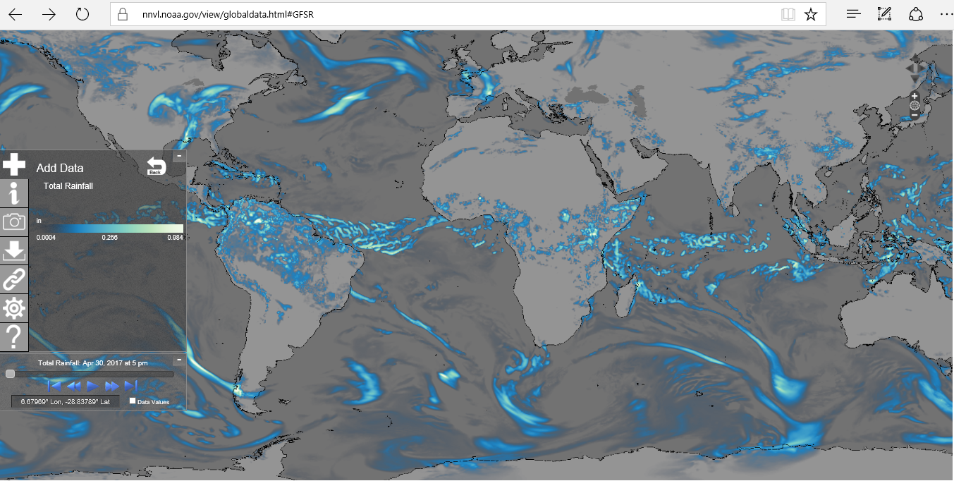

Source: US National Oceanic and Atmospheric Administration

*Figure 2.2-2 Total Rainfall Predicted May 10, 2017*

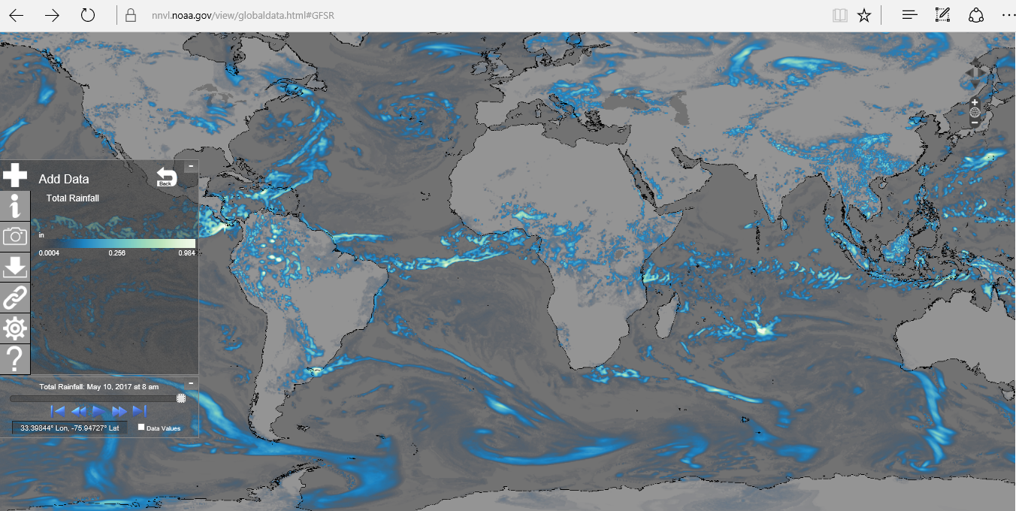

Source: US National Oceanic and Atmospheric Administration

*Figure 2.2-3 NOAA Global Forecast System*

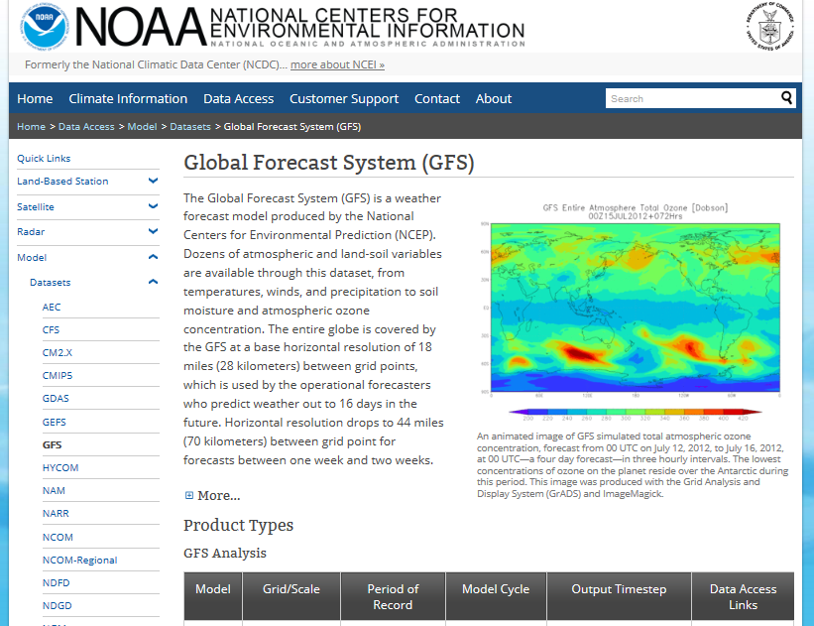

Source: US National Oceanic and Atmospheric Administration

Another very good resource of geospatial maps which provide insight can be found on local television stations. Take a look at this series of examples that show how these maps are used to inform:

*Figure 2.2-4 US Daily High Temperature Map*

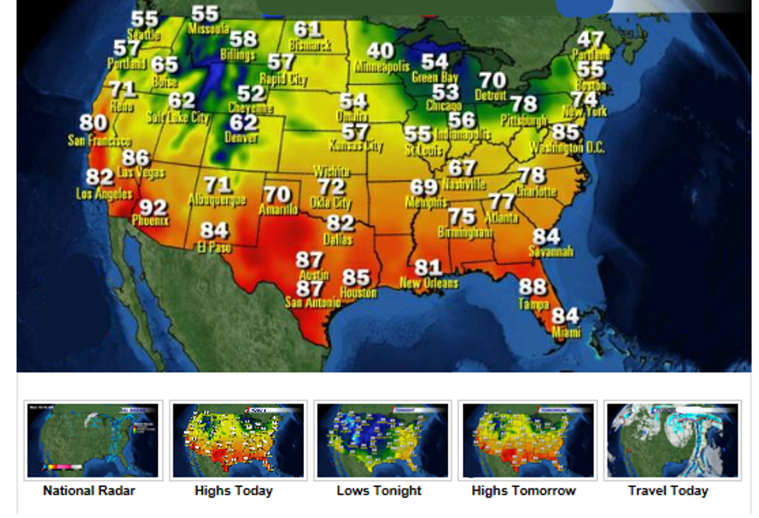

*Figure 2.2-5 Central Florida Temperature Map*

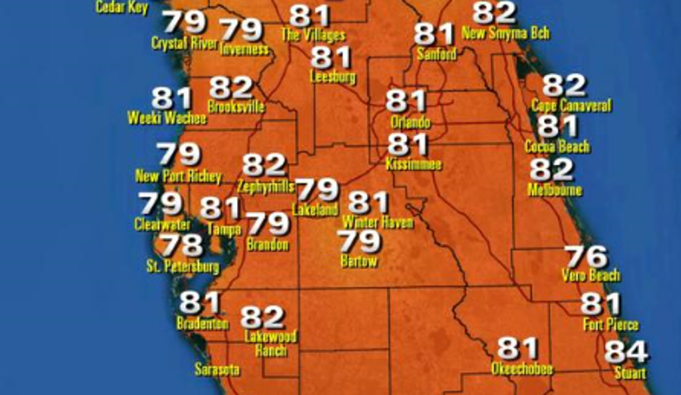

*Figure 2.2-6 FL Traffic Conditions*

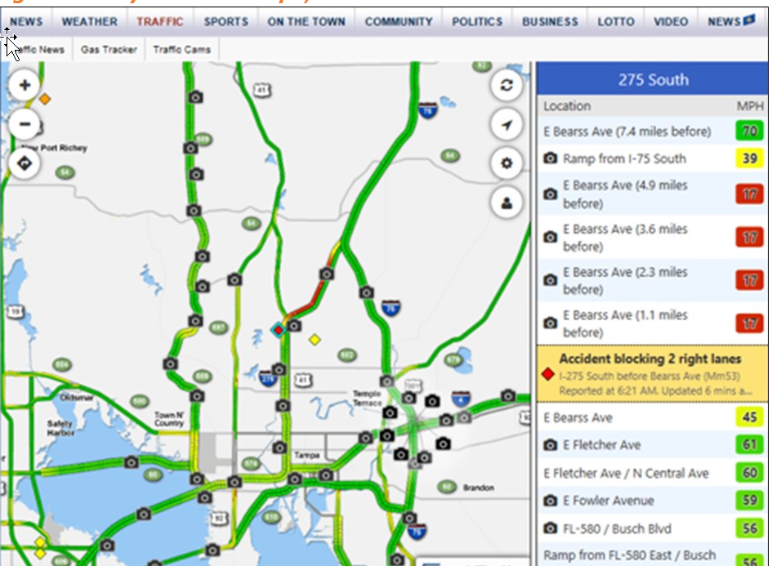

Each of the geospatial maps above take a different approach to conveying information, but all effectively share data. Figure 1 provides the user with an overview of rain fall around the globe. This allows the user to compare various regions of the world.

Figure 4 provides a heat map of temperatures throughout the United States which is overlaid with specific temperatures from cities in select states. While the state names have been suppressed, a user with an understanding of geography can easily determine the relative temperature in their home state. A more detailed map of the central Florida region follows, and includes both the temperature as well as the city name.

Finally, the last geospatial map, is an overlay of the Tampa Bay area showing traffic conditions on primary roads. This map is useful for users to get an understanding of traffic conditions before venturing out to a particular destination. Although this map comes directly from the Bay News 9 website, there are many apps available on mobile devices which provide similar information. These apps serve as data visualization tools that embed geospatial map features combined with contextual elements that provide locations for food, gas, shopping, health centers, and other points of interest.

**Geocoding Data in MS Excel**

Since MS Excel is one of the most extensively used tools in business, it would be prudent to review how geocode data can be used to produce maps in MS Excel. First the user must understand that MSExcel contains add-in features which enable some of these capabilities. Microsoft has constantly been embedding data analytic features into newer versions of MSExcel with add-in features being included as standard features in the last three releases. Geocoded data in MSExcel will be presented as a latitude and longitude coordinate value.

*Figure 2.2-7 Example of Coordinate System*

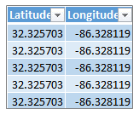

*Figure 2.2-8 Example of Map in Excel’s Power Map Feature*

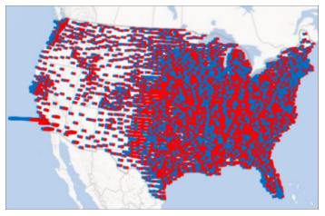

MSExcel 2013 has a feature calls Power Map which supports several geocoded formats including:

* Latitude/Longitude
* Street Address
* City
* County
* State/Province
* Zip Code/Postal Code
* Country/Region

This capability is commonly found in data visualization tools such as MSExcel, Tableau, SAS, QlikView, and JMP.

Another very popular use of data visualization maps comes from politics and election results. Take a look below at Figure 9 the 2016 US Presidential Election Results. The features of the map include images of the republican and democratic candidates, color coded states which outline a US map, and electoral vote counts. From this map, a user has a good understanding of how the election.

*Figure 2.2-9 2016 Presidential Election Results*

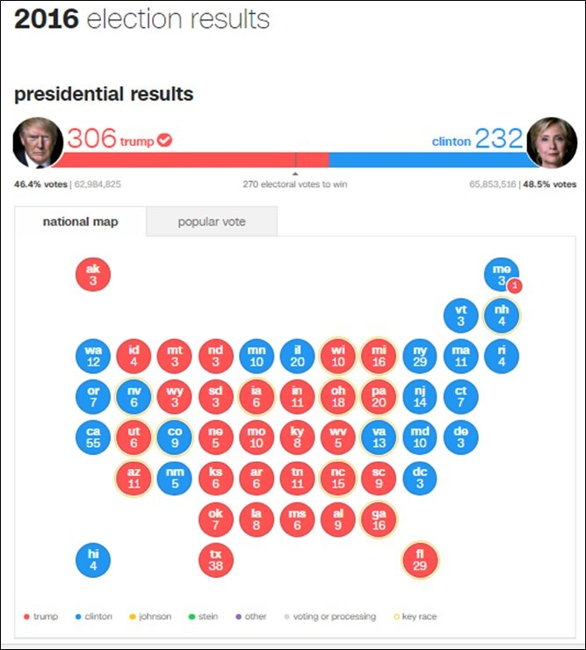

The Congressional election results were organized in a different manner, using the layout of seats of the House to show the number of votes for republicans and democrats. This is an effective visualization that incorporates both the numerical values with a political representation.

*Figure 2.2-10 2016 Election House of Representatives Results*

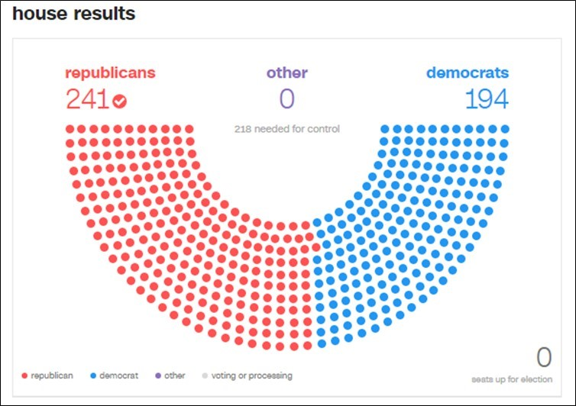

Module 02 Lab Lecture

The purpose of this lab lecture is to provide you with background and guidance to complete the Module 02 Lab. In Module 01, you should have completed your download and registration of the Tableau software. **Please review these instructions in Module 01 if you have not completed that step.**

Tableau is a new tool for many people, so Tableau offers free video tutorials on their website. The free video library is accessible in the Tableau Learning Center at <https://www.tableau.com/learn/training>. Go to this link and view the video called **The Tableau Interface**. Below is an example of what the video link looks like:

*Figure L2-1 The Tableau Interface Video*

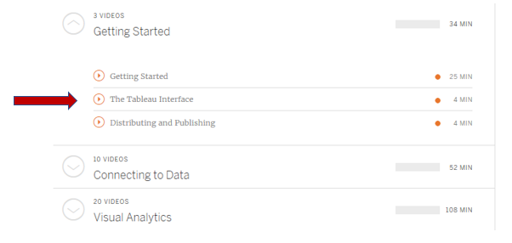

You will also need to download the exercise workbook that accompanies The Tableau Interface video. In order to access the exercise workbook, you must first login to view “The Tableau Interface” video. Once the video is launched, the exercise workbook becomes available. The image below shows where to find the link to download the exercise workbook.

*Figure L2-2 The Exercise Workbook*

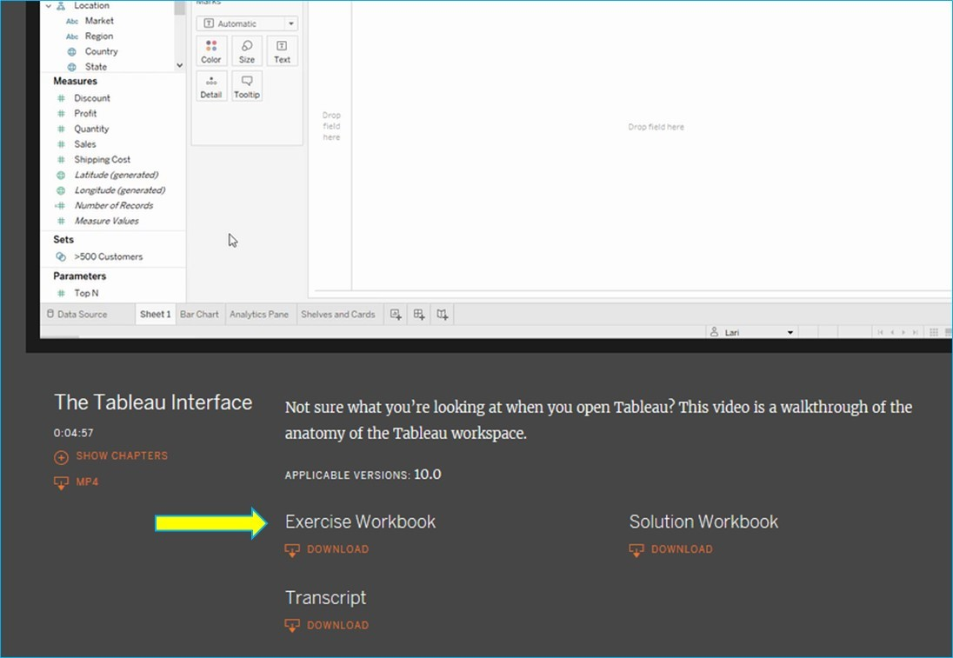

Once you have downloaded the Tableau for Students software, viewed The Tableau Interface video, and downloaded the Exercise Workbook, you can complete the Module 02 Lab. This first lab focuses on getting accustomed to features of Tableau by making changes to a Bar chart. The Lab assignment also asks you to select a particular area of the bar graph and determine the sales and profit of a geographic area. These values are to be recorded as part of the submission.